Variable (Let, Const) Let- when value will change / Const -when value should not change
- Variable
- Data Type (Number, String, Boolean, Null, Undefined)

Example of variable and data type
Water (Means Data)

Rice (Means Data)

Variables Let / Const /
Const Value cannot be changed
• let = keyword ( is a keyword used to declare a variable )
• name = variable ( identifier / variable name )
• "dipkiran" = value (specifically, a string literal)

//object {}
let person {
name : "dipkiran" //string
address : "Dharan" // string
number : 123333 // number
age : 42 //number
}

Variable is just like a container which store different type of data. Variable sf] types x'G5 . Tof] xf] Data Types ES6 Develop from 2014.
Data Types :
// String "Dipkiran" 'dipkiran' '1"
let name = "DipKiran"

// Number 1 2 3 4 5.1 6.7 8.0
//1 2 3 4 integer number
//2.3 4.5 float number

let a= 5; //integer number
let b = 1.5; // float number

// boolen true false
let flag = false;

//undefined
let country;
//bracket
//null
let city = null;

Glass (Variable)
Plate (Variable)
Arrey :- eg]sf] Pp6f emf]nf xf] eg]/ ;lDemg' . hxf Pp6} lsl;dsf] 9f6fx? sn]S;g x'G5 . h:t} lrgLsf] Jofu leq lrgL dfq x'G5 x? ld;fPsf] x'b}g . Collection of Same type of Data. Array nfO{ [ ] o;/L n]lvG5 .
let jhola = [1,2,3,4,5];

Operators
Arithmetic Operator leq s] s] k5{ eGbf (+ - / * % ) s'g}
klg lx;fj lstfj ug'{ k/f] eg] Arithmetic Operator sf] k|of]u ul/G5 .
let a = 5;
let b = 10;
let c = (a+b);
console.log (c);

Assignment Operator
+= -= /= *= %=
let a = 9;
a += 2;
console.log (a);
Result (11)
- a += 5; o;/L n]Vbf xfldn] a sf] value 5 n]v]sf] x'gfn] 9+5 hf]8]/ o;sf] Result 11 cfp5 . //a = a + 5

Comparison (Relational Operator )
Used to compare values → result is true or false.
> < == >= <= != ===
(> Greater then) (< less then ) (== equal to) (>= Greater or Equal) (<= Less or Equal) (!= Not Equal) (=== Aject Equal)
Relational Operator hlxn] klg xfld condition df use u5f} . condition nfpbf v]/L h:t} If, while, lt/ Relational Operator nfO{ apply u5f} .
Conditions
- if, else, else if
let a = 9;
if (a == 10){
console.log ("10 is Greater then 9");
}
else{
console.log ("Now Equal");
}
pbfx/0f M olb ( / !) a/fj/ xf] eg] "Print Equal" olb Value a/fj/ xf]Og eg] "Print Not Equal".
Logical Operator
(&& and) (|| or) (! not)
Logical Operator rflx xfdLn] User Name or Password cyjf Form Validation ug{ sf] nflu k|of]u u5f} .
let username = "dipkiran1";
let password = "123";

if (username == "dipkiran" && password == "123"){
console.log ("Login Sucessfull");
}

else{
console.log("Login Fail");
}

Increment and Decrement
increment ++
decrement --
let a= 10;
console.log (++a);
console.log (a++);

If / Else
s]xL s'/fx?nfO{ compare ug'{ k/f] eg] If cyjf Else sf] k|of]u u/LG5 .
let keyTimiLaiBhokLago = "";
if(keyTimiLaiBhokLago == "yes"){
console.log ("Babu timi khana khau");
}
else{
console.log("xoina vhane nacha");
}

Switch

let day = 3;

switch(day){
case 1:
console.log("Sunday");
break;

case 2:
console.log ("Monday");
break;

case 3:
console.log("Tudsday");
break;

default:
console.log("there are 03 days in a week");
}

Loops
- for loop - कति पटक loop चल्ने हो पहिल्यै थाहा हुन्छ
- for (initialization; condition; increment/decrement) { // code }
- while loop ha ;DDf कति पटक loop चल्ने हो थाहा हुँदैन
- / do loop
03 Types of Loop
While Loop ha ;Dd d]/f] lyvf{ d]6Lb}g\ tj ;Dd kflg lkp5' .
For Loop
Do While
Pp6} s'/fnfO{ Repet u/]/ b]vfpg' nfO{ Loop elgG5 . klxn] xfldn] hello world nfO{ @ rf]6L print ug'{ nfO{ @ rf]6L console.log("Hello World"); n]Vg' kYof]{ . olb Hello World nfO{ !)) rf]6L lk|G6 ug]{ kg]{ eof] eg] !)) rf]6L console.log("Hello World"); n]Vg' kYof]{ . cj While Loop sf] k|of]u u/]/ Hello world nfO{ Pp6} Code df !)) rf]6L b]vfpg ;lsG5 .

//while (ha ;Dd) loop - jaba sama

let a = 1;
while(a <= 10){
console.log(a);
a++; // increment last ma hunxa.
}
_______________________________________________________________________
let count = 1;
while (count <= 20){
console.log(count + "..Dipkiran");
count++;
}
_________________________________________________________
let a = 1;
while (a <= 10){
if(a % 2 ==0){
console.log(a);
}
a++;
}
//For loop
for (a=1; a <= 10; a++){ //incrment first ma hunxa
console.log(a);
}

Function
Function eg]sf] Pp6f block of code xf] x/]sf] buttom sf] Pp6f function 5 ah ;Dd To;nfO{ lylrb}g\ cyjf k|f]ufdLsf] efiff df Call ul/b}g\ To;n] sfd ub]{g\ . ha ;Dd tkfO{ l6eLsf] l/df]6 sf] ! gDj/ j6d lyRg' x'Gg tj ;Dd tkfO{sf] Rofgn RofGh x'b}g\ . Function df n]vLg] lrh nfO{ Statement elgG5 / Funcation sf] gfd lbbf u/L hlxn] klg Camel Case df n]Vg'xf];\ .
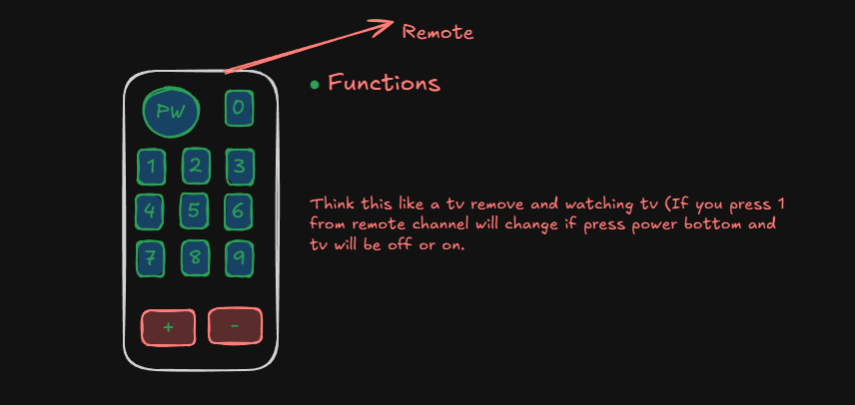
tkfO{n] Function nfO{ call g ubf{ ;Dd Console df b]vfpb}g \ pbfx/0fsf] nflu
function sayHello (){
//Statement
console.log ("hello World");
}
sayHello();

- Courly Bracket open / Close leqsf] sf]8 nflu block of code elgG5 .

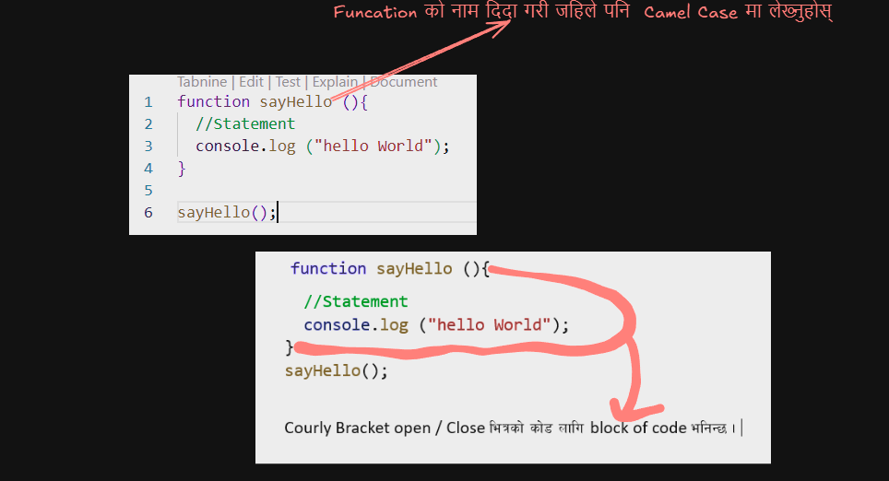
function sayHello (){
//Statement
let a = 10;
let b = 15;
let c = (a+b);
console.log (c);
}
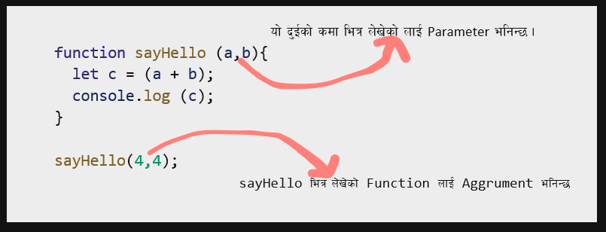
sayHello();

- Parameter eg]sf] Function df declear ubf{ lbO{sf] Variable nfO{ parameter elgG5 . ha Tof] Function nfO{ Call ubf{ Tof] Parameter sf] Value lbO{G5 To;nfO{ Aggrument elgG5 .

Function Expression
let sayHello = function(){
console.log("hello world");
}

Arrow Function
let sayHello = (a,b) =>{
let c = a + b;
console.log(c);
} // Mostly used in React arrow function

--------------------------------------------------------------------------------
// Using if Inside the Funciton
function checkLogin(isLoggedin){
if(isLoggedin){
console.log("Welcome Back");
}
else{
console.log("please log in");
}
}
checkLogin(true);

--------------------------------------------------------

function greeting(){
let hours = 10;
if(hours < 12){
console.log("Good Morning");
}

else if (hours < 18){
console.log("Good After Noon");
}
else {
console.log("Good Night");
}
}

h'g Function sf] gfd 5f]Og To;nfO{ anonymous function elgG5 .
Template Literals
of] ;a} Value nfO{ Pp6f Sentence df n]Vg' k/f] eg] Template Literals sf] k|of]u u/LG5 . o;nfO{ rflx contimination elgG5 .
Agrument af6 parameter df data k7fp'gnfO{ fuction parameter elgG5 .

function myFunction(name){
console.log("hello", name)
}
myFunction("Ram");

// forEach() // map() // filter() // find()
For loop, while loop, do while loop o:tf] vfNsf] loop normaly xfld x? Java script df use ub}gf} . xfdL forEach(), map(), filter, find use u5f} .

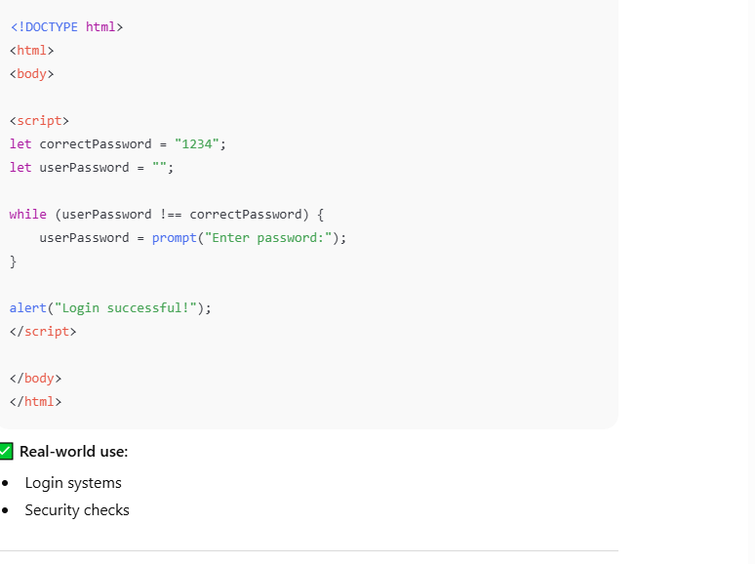
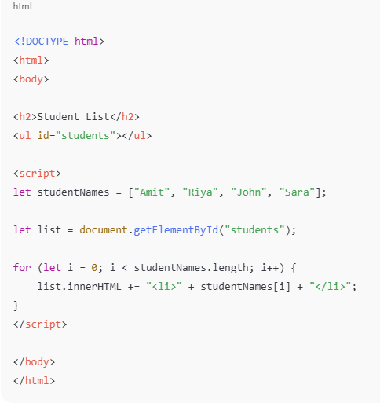

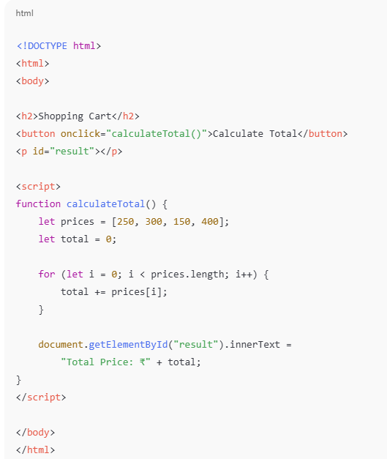

Task.
- if the marks is above 60 print A Grade if the mark is above 80 print A+ if the mark is less then 60 print fail using relation operator.
- If 9 is greater 10 then print A is greater using relation operator.
- User name and password wrong using logical operator.
- 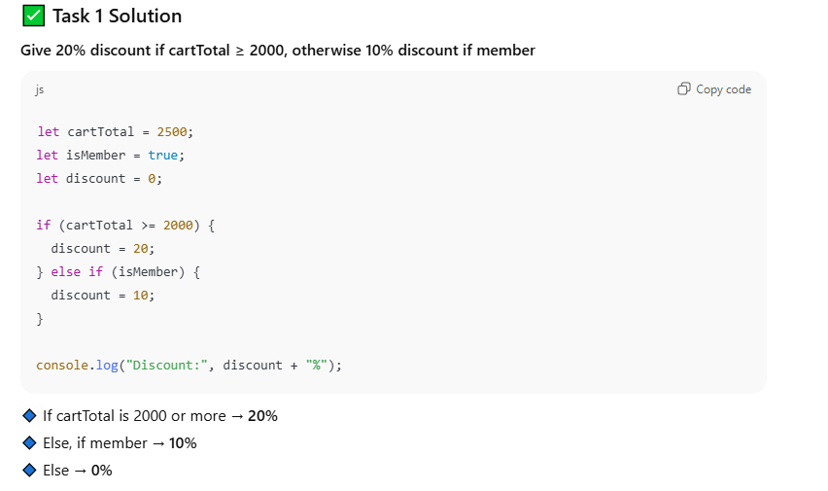

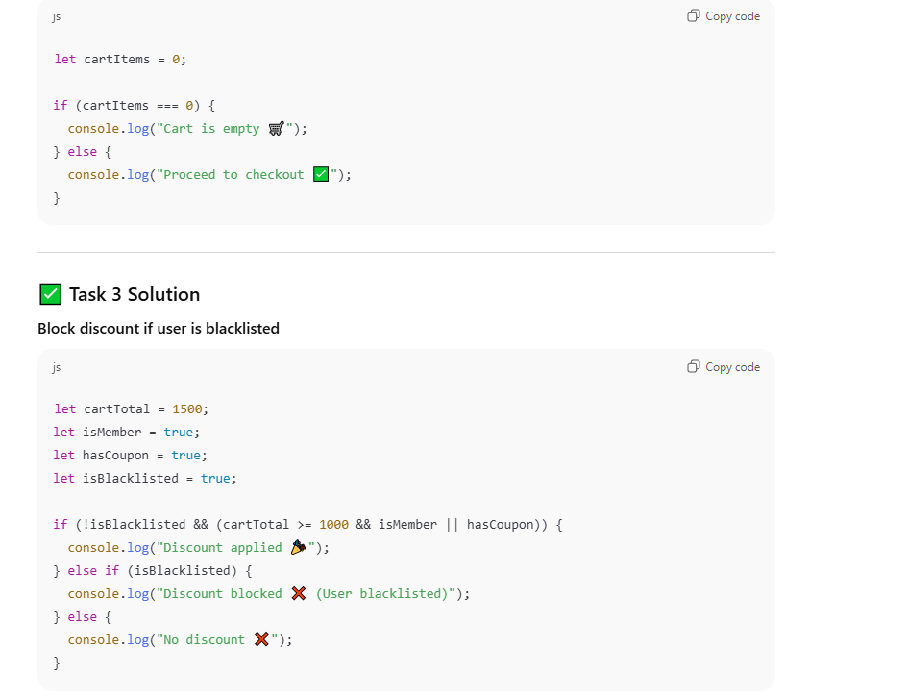

let name = "Dipkiran";
let hour = new Date().getHours();

if (hour >= 5 && hour < 12){
console.log ("Good morning," + name);
}
else if (hour >= 12 && hour < 17){
console.log ("Good Afternoon," + name);
}

else if (hour >= 17 && hour < 21){
console.log ("good Evening," + name);
}
